NAME: _________________________________________ PERIOD: _______ DATE: ______

LAB PARTNERS: ______________________________________________________ LAB #4

EARTH SCIENCE, MATH, AND YOU

INTRODUCTION
Throughout your study of Earth Science, you will use equipment to help you observe and measure earth materials in the laboratory. You will also be called upon to demonstrate some simple math skills. Not only must you be able to calculate problems such as percent deviation and rate of change, but you must also be able to correctly divide using a calculator, round to the nearest tenth, and use scientific notation. In this lab you will practice these math skills.

OBJECTIVE
During this investigation you will be able to:
- Round to the nearest tenth
- Converting in and out of scientific notion
- Subtract time
- Calculate percent deviation and rate of change
- Determine rate of change from a graph

MATERIALS
Calculator
Ruler
Earth Science Reference Tables

PART 1
ROUNDING OFF

When performing calculations, answers frequently come out uneven, with many decimal places. In this course, unless otherwise directed, you are expected to round off all answers to the nearest tenth (one place after the decimal point). For example:

- would be rounded to 97.3 139.42 would be rounded to 139.4

Round off the following numbers to the nearest tenth.

- 10.76 ________________ 5) 1.544 _________________

- 1369.07 ______________ 6) 0.09 _________________

- 0.134 ________________ 7) 10.02 _________________

- 0.9831 _______________ 8) 12.005 ________________

PART 2
DIVISION

EXAMPLE ONLY: The mathematical procedure of division can be written many ways. For example, the problem of 4 divided by 5 can be written any of the following ways:

- 4 ÷ 5 B) 4/5 C) 4 D) 5 4
5
When performing division on a calculator, the keystrokes should follow the method in the example above.

Solve the following division problems, rounding off all answers to the nearest tenth.

- 75 105 ______________ 12) 20 _______________
65
- 36 / 7 ______________
13) 10000 _______________
11) 13.2 ÷ 6 _____________ 77000

14) 53 _________________
267

PART 3
SCIENTIFIC NOTATION

Values that are used in scientific can be very large. One way to make these numbers more manageable for calculations is to use scientific notation. In scientific notation, a value is expressed as a number between q and 10 multiplied by a power of ten in exponential form. For example the distance from the sun to the nearest star, Proxima Centauri, is about 40 trillion kilometers. The number 40 trillion equals 40,000,000,000,000. This number expressed in scientific notation is 4.0 x 10¹³. Another example is when the size of a pebble is measured it is found to be 25 ten-thousands of a meter across. This number equals 0.0025. When expressed in scientific notation it is written 2.5 x 10⁻³. Express the following numbers in scientific notation.

- 3,700 ___________________ 18) 0.250 ________________________

- 87,000,000 _______________ 19) 0.03 _________________________

- 120 _____________________ 20) 0.000,000,1 ___________________

Express the following numbers as they should be written.

21) 3.3 x 10⁸ _________________ 24) 5.8 x 10⁻⁵ ____________________

22) 4.9 x 10¹⁰ ________________ 25) 1.7 x 10⁻² ____________________

23) 1.0 x 10³ _________________ 26) 1.0 x 10⁻⁸ ____________________

PART 4
SUBTRACTING TIME

PROCEDURE
Important:
- Borrowing and carrying in regular math means exchanging 10 ones for a ten (or 10 tens for a hundred, etc.).
- Borrowing and carrying in time math mean exchanging 60 minutes for an hour and 60 seconds for a minute.
When subtracting time you do not look at each digit. You look at the minutes as a whole. In the problem below you cannot subtract 52 minutes from 15 minutes (15 - 52 = ?), because 15 is smaller. You must borrow.
5 hours 15 minutes 11 sec
- 1 hour 52 minutes 47 sec
???????????????
Go to your minutes and take 1 away. (15 - 1 = 14 hours)
You now have 14 minutes.
A minute equals 60 seconds. You add the 60 seconds to the 11 seconds.
(60 + 11 = 71 minutes) This gives you 71 minutes. Repeat the same steps but borrow from the hours to increase the minutes. Your problem now looks like this:
4 hours 74 minutes 71 seconds

- 1 hour 52 minutes 47 seconds

Now you are able to subtract.
4 hours 74 minutes 71 seconds
- 1 hour 52 minutes 47 seconds
3hours 22 minutes 24 seconds

Try the problems below using the procedure above:

- 2:50:45 28) 4:21:22 29) 8:28:37
- 2:50:31 - 4:18:22 - 8:22:53

- 4:28:53 31) 9:15:24 32) 8:02:03
- 3:52:41 - 2:16:25 -7:59:59

PART 5
SOLVING EQUATIONS

PROCEDURES
Solve each of the following problems using the steps below:
- State the formula (page 1 of the ESRT)
- Substitute data in the formula
- Solve and round to the nearest tenth
- Label answer with correct units

HIP HEIGHT

The hip height of a dinosaur can be calculated from the length of its footprint. Hip height is defined as the straight line distance from where the leg connects to the hip to the floor. The formula relating these variables is:

Using the following equation and the steps stated above, solve the following problems:

Hip Height (H) = 4.5 x footprint length (FL)

- Velociraptors had a footprint length of 0.2 meters. Calculate their hip height.

Answer ___________________

- Brachiosaurs had a footprint length of .56 meters. Calculate their hip height.

Answer ____________________

- Diagram I is the sketch of a Dilophosaur print from Dinosaur State Park in Connecticut, actual size. Calculate its hip height.

Answer ____________________________________

- Diagram II is the sketch of a Grallator print from New Jersey, actual size. Calculate its hip

Answer __________________________

RATE OF CHANGE

- At birth (0 years), a Maiasaur was .2 meters long. At the age of 11 years it was 7.5 meters long. Calculate its rate of growth in meters per year.

Answer _______________________

The data table below shows the air temperatures recorded both inside and outside a greenhouse on a sunny day.

Time | Outside Temperature | Inside Temperature
6 am | 10 C | 13 C
8 am | 11 C | 14 C
10 am | 12 C | 16 C

12 noon | 15 C | 20 C

2 pm | 19 C | 25 C
4 pm | 17 C | 24 C
6 pm | 15 C | 23 C

- Based on the data table above, calculate the rate of temperature change outside the greenhouse from 6 am to 12 noon.

Answer ______________________________

- Based on the data table above, calculate the rate of temperature change inside the greenhouse from 2 pm to 6 pm.

Answer ___________________________

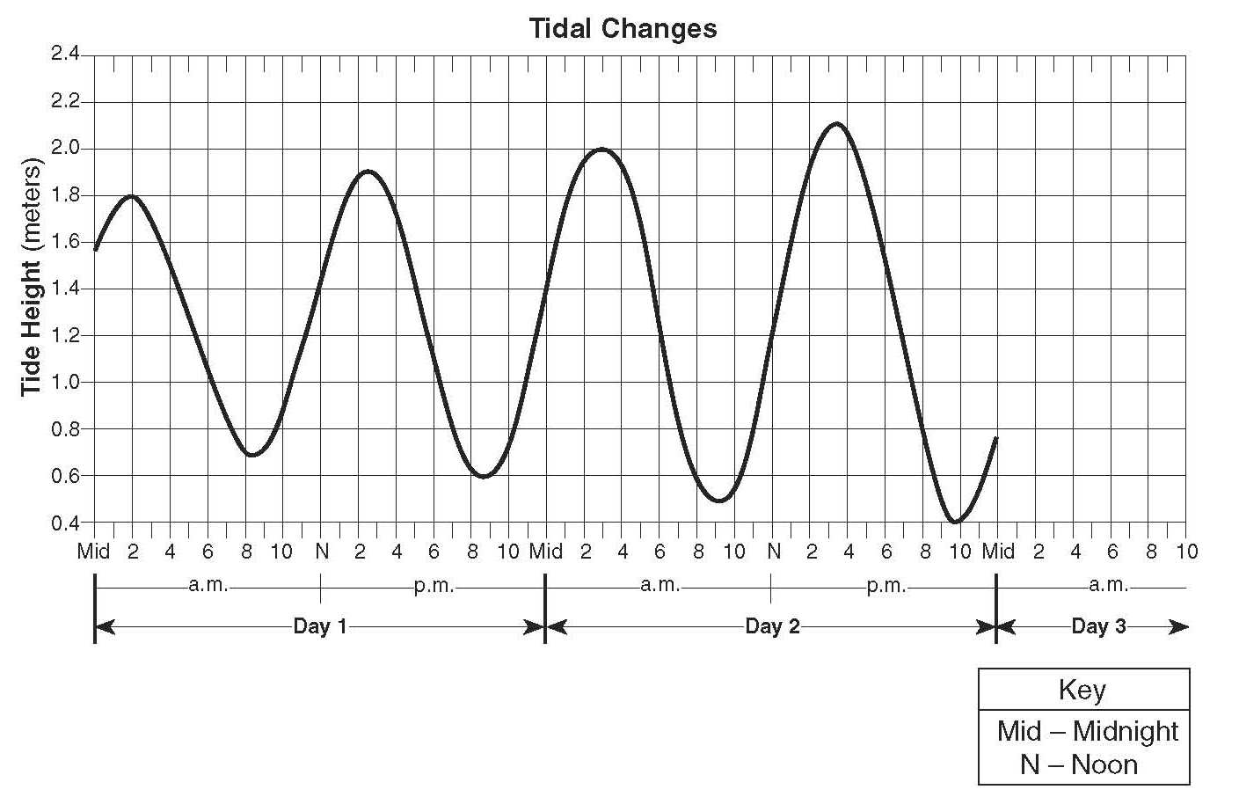
- Calculate the rate of change in the height of the tides from 6 a.m. to 1 p.m. on day 1.

- Calculate the rate of change in the height of the tides from 11 p.m. on day 1 to 3 a.m. on day 2.

- If the pattern shown continues, predict the most likely height and time for the first high tide on day 3.

OPTIONAL: PERCENT ERROR

- A student is weighed in the nurse’s office and is told that he weighs 150 lbs. He tells the nurse the scale is wrong, that he actually weighs 132 lbs. Calculate the percent deviation. Round off your answer to the nearest tenth and show all work.

Answer ____________________

- Based on the skeleton of Triceratops, a paleontologist determines that its eggs were 55 cm wide. An earth science teacher (from Sachem of course!) discovers an actual triceratops egg on one of his collecting trips, and it measures 72 cm wide. Calculate the percent deviation. Round off your answer to the nearest tenth and show all work.

Answer ____________________

- A student measured the density of a copper penny to be 5.5 g/cm³. The accepted value is 5.9 g/cm³. What is the percent deviation? Round off your answer to the nearest tenth and show all work.

Answer ____________________

