NAME: _________________________________________ PERIOD: _______ DATE: ______

LAB PARTNERS: ______________________________________________________ LAB #6

LOCATING POSITIONS ON THE EARTH USING LATITUDE AND LONGITUDE

INTRODUCTION
To determine locations on the Earth’s surface, you must have points of reference. A coordinate system, which is a system of imaginary lines, has been developed. The latitude-longitude coordinate system is the most commonly used system to locate places on the Earth’s surface. Latitude is the angular distance north or south of the equator. Longitude is the angular distance east or west of the prime meridian. In this lab you will be using different views of the Earth’s latitude-longitude system to locate and describe locations on Earth’s surface.

MATERIALS
World map
Globe
Pencil with eraser

APPROXIMATE TIME 2 periods

OBJECTIVES
To determine positions on the earth using the coordinate system of latitude and longitude.

PROCEDURES:
- Answer questions 1 and 2 in Part I.
- Using the coordinates of latitude and longitude provided in Part II; plot these on the attached world map.
- Find letters I-P on the world map and determine the latitude and longitude for each location.
- In Part 4, find the cities listed and determine their latitude and longitude by using the world globe.
- Answer lab questions in Parts 5, 6, and 7.

PART 1

1a. From what reference line on the earth is latitude measured? __________________________

1b. What is the latitude of this line? ________________________________________________

2a. From what reference line on the earth is longitude measured? _________________________

2b. What is the longitude of this line? _______________________________________________

2c. Through what city does this line pass? ___________________________________________
PART 2

On the world map (page 40), place a letter at the following coordinates. Then use a highlighter or colored pencil to color over the letter.

A 10° N, 50° E

B 30° N, 10° E

C 40° S, 25° E

D 55° S, 100° E

E 60° N, 135° W

F 65° N, 120° W

G 70° S, 115° W

H 75° S, 75° W

PART 3

On the world map, find the following points and determine their latitude and longitude.

 | LATITUDE | LONGITUDE
I
J
K
L
M
N
O
P

PART 4

Using a globe, determine the latitude and longitude of the following cities?

CITY | LATITUDE | LONGITUDE
San Francisco
New York City
Mexico City
Paris
Moscow
Tokyo
Sydney
Cape Town
Buenos Aires
Baghdad

PART 5

QUESTIONS

- What is the latitude of the North Pole? _________________

- Explain why any two lines used to determine latitude never can touch each other.

________________________________________________________________________

- You are on a boat which is crossing the Prime Meridian. The altitude of Polaris is 50º. Explain how you know the boat's location is 50º North latitude and 0º longitude.

________________________________________________________________________

- Explain why the distance between two meridians at the North Pole is 0 miles.

________________________________________________________________________

- What is the maximum number of degrees of longitude possible? ____________
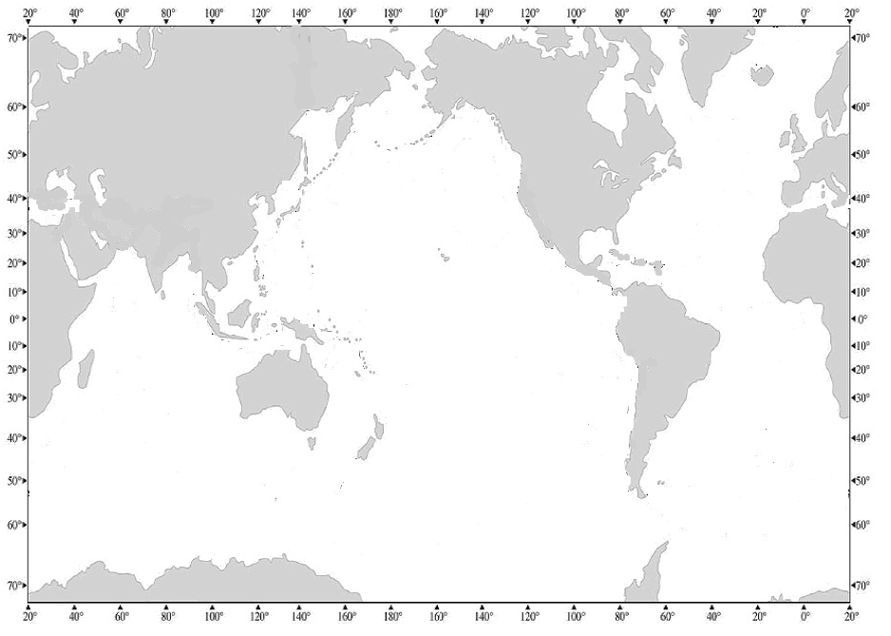
P
O
N
L
M
I
J
K

PART 6

PROBLEM SOLVING
(Answer these questions in complete sentences)

- Is it possible for a city to be located at 115º S latitude and 25º W longitude? Explain.

________________________________________________________________________

________________________________________________________________________
- What is located at the following coordinates?
40° South Latitude
80° East Longitude

________________________________________________________________________

________________________________________________________________________
- What happens to the distance between longitude lines as one moves from the North Pole to the Equator? Explain.

________________________________________________________________________

________________________________________________________________________

- Using your ESRT, what is the approximate latitude and longitude of your school?

_______________________________ _________________________________
- There is an old phrase “Digging a hole through the Earth’s center would bring you out in China.” If you could drill a hole from Long Island straight through the Earth’s core, where would you in fact come out?

________________________________________________________________________

________________________________________________________________________

________________________________________________________________________

PART 7

LATITUDE/LONGITUDE IN NEW YORK STATE

Using the map on page 3 of your Earth Science Reference Tables entitled “Generalized Bedrock Geology of New York State,” answer the questions below.

- What city is located at the following coordinates?

LATITUDE | LONGITUDE | LOCATION
40°45’N | 74° W
43°15’N | 77°37’W

- Give the latitude and longitude, to the nearest minute, of the following locations:

LOCATION | LATITUDE | LONGITUDE

ELMIRA

MASSENA

PART 8
Views of the Earth’s northern or southern hemisphere can be represented by showing a polar view of the Earth’s latitude and longitude system. In this type of map, for the northern hemisphere, the North Pole is in the center of the map representing a latitude of 90º N. The rest of the latitude lines are drawn as circles. Longitude lines are shown drawn from the pole to the outside of the map. Use the map on the next page to learn to interpret plotted points as well as plot points using a polar version of the latitude-longitude system.

LATITUDE/LONGITUDE POLAR VIEW

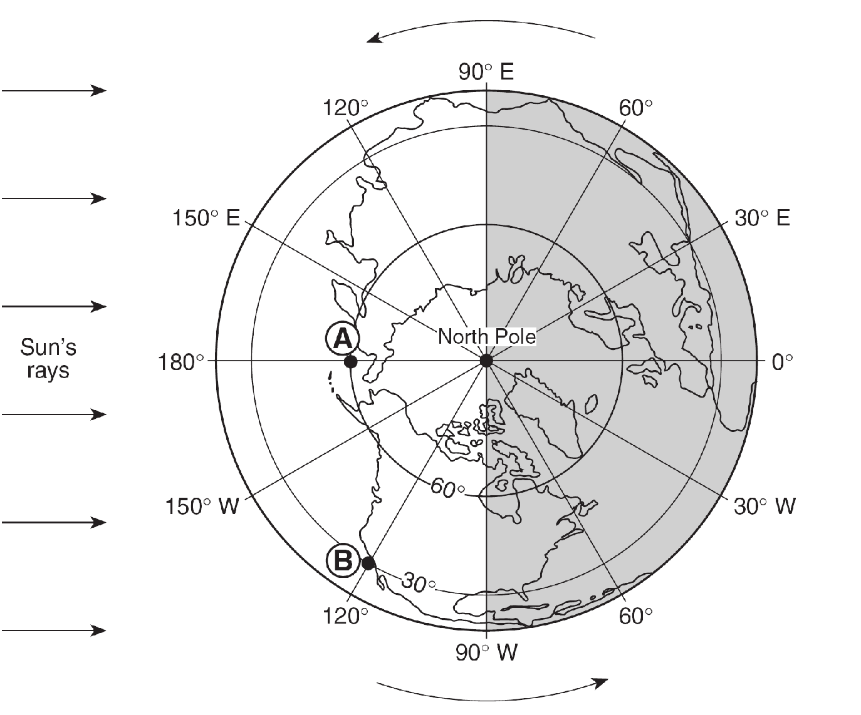

Using the map above, answer the questions below:

- What is the latitude and longitude of point A?

______________________________ ________________________________

- What is the latitude and longitude of point B?

______________________________ ________________________________

- Plot point C using the following coordinates: 45°N 30°E

- Plot point D using the following coordinates: 75°N 120°W

- Which of the two lettered points have same solar time? Explain.

______________________________________________________________________
PART 9

TELLING TIME ON EARTH

Use the diagram to the right to answer questions 1 through 5.

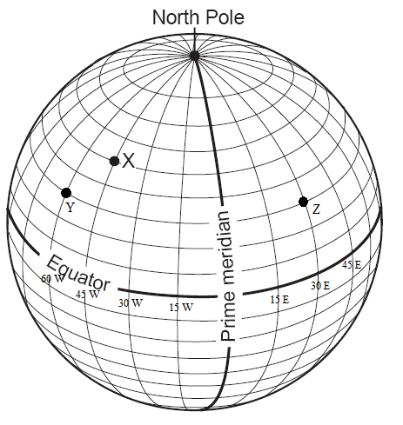
- What is the rate of the Earth’s rotation? __________________

- For every 15˚ of longitude time changes by ________ hour(s).

- In this diagram of the Earth longitude lines are ____________ degrees apart.

- If it is 3 PM at point X, what time is it at point Y? _________

Point Z? ___________

- If it is 4 AM at point Z what time is it at point X? __________

Use the diagram below to answer questions 6 through 9.

- In this diagram of the Earth longitude lines are _____________ degrees apart.

- If it is 9 AM at Point D, what time is it at Point C? ______________ Point E? ___________

- Which two lettered locations have the same time?

Explain:

___________________________________________________________________________

- Explain why the time zones are 15˚ of longitude apart.

___________________________________________________________________________
